**Experiment 1**  
By Kushagra Agarwal  
500125138  
Batch 1 IOT  
<https://github.com/Kushonwork>

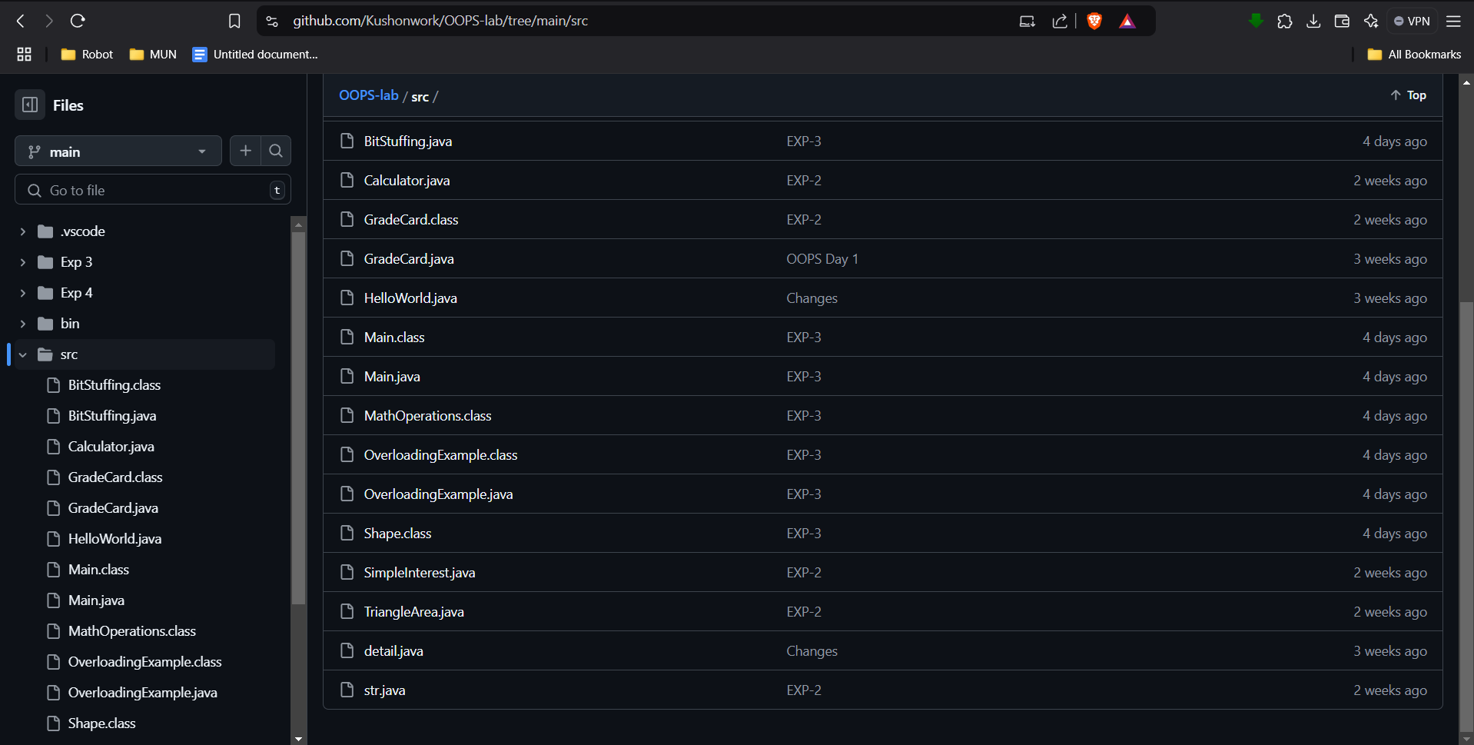

Task 3: Sample Hello World Program

public class HelloWorld {

public static void main(String[] args) {

System.out.println("Hello, World!");

}

}

Task 4: Display Name and Address on Different Lines

public class NameAndAddress {

public static void main(String[] args) {

System.out.println("Your Name");

System.out.println("Your Address");

// Replace "Your Name" and "Your Address" with your actual name and address

}

}

Task 5: Visually Appealing Grade Sheet

public class GradeSheet {

public static void main(String[] args) {

System.out.println("***************************");

System.out.println("* GRADE SHEET *");

System.out.println("***************************");

System.out.println("\nSubject\t\tMarks\tGrade");

System.out.println("---------------------------");

System.out.println("Math\t\t 85\t A");

System.out.println("Science\t\t 90\t A+");

System.out.println("English\t\t 78\t B+");

System.out.println("History\t\t 82\t A");

System.out.println("Geography\t 88\t A");

System.out.println("---------------------------");

System.out.println("Total\t\t 423\t A");

System.out.println("***************************");

}

}